26.34: a) When the wires are shorted, the full-scale deflection current is obtained:
b) If the resistance 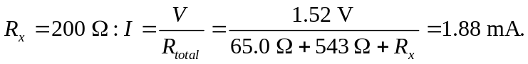
c) 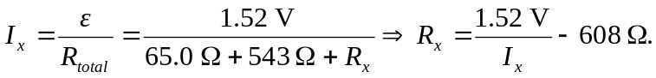
So: